**SINO HAS data Format**

**HAS message structure**

|  |  |  |  |
| --- | --- | --- | --- |
| Message Header | Reserved | HAS Page | CRC |
| 224 | 2 | 512 | 32 |

**SINO message header**

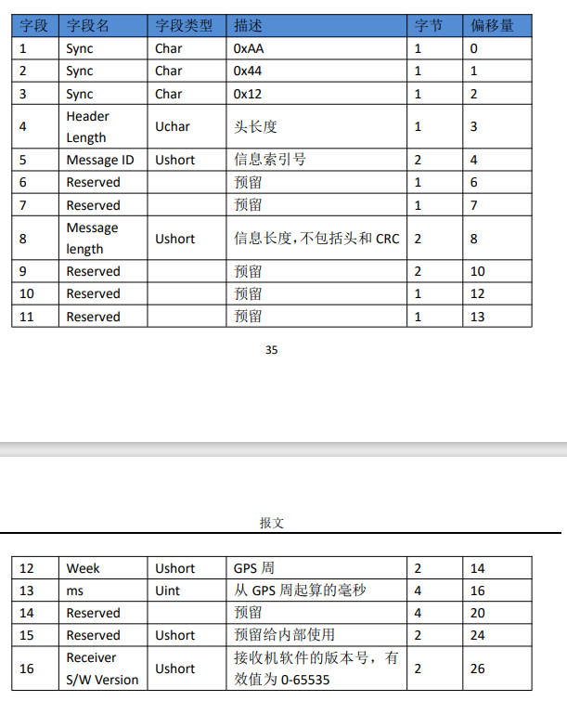

**HAS raw message**

Galileo_HAS_SIS_ICD_v1.0：

|  |  |  |  |  |
| --- | --- | --- | --- | --- |
| C/NAV Page | | | | Total(bits) |
| Reserved | HAS Page | CRC | Tail |
| 14 | 448 | 24 | 6 | 492 |

The actual length of the data segment is 512 bits, slightly longer than the HAS page (492). The additional space is typically padded with zeros, which users need not concern themselves with.

**CRC**

Using a 32-bit CRC redundancy check, the verification content includes:

|  |  |  |
| --- | --- | --- |
| Message Header | Reserved | HAS Page |